**Excel Assignment - 8**

1. What do you mean by AutoComplete feature in Excel and what are the

benefits of using this feature?

In Microsoft Excel, the AutoComplete feature automatically suggests and completes the entry of text or numeric values based on previously entered data in the same

column. As we start typing a value in a cell, Excel looks at the existing entries in that column and provides a dropdown list with potential matches.

This allows us to select from the list, and Excel will complete the entry with the closest match or the entire value if there's an exact match.

Benefits:-

Time-Saving

Consistency

Error Reduction

Efficiency

Data Validation

User-Friendly

Learning from Past Entries

Customization

2. Explain working with workbooks and working with cells.

Working with Workbooks in Microsoft Excel:

Creating a New Workbook

Opening an Existing Workbook

Navigating Between Worksheets

Adding and Deleting Worksheets

Renaming Worksheets

Saving Workbooks

Working with Cells in Microsoft Excel:

Entering Data

Editing Data

Copying and Pasting Data

Formulas and Functions

Relative and Absolute References: Cell references in formulas can be relative or absolute. A relative reference changes when copied to another cell,

while an absolute reference stays fixed. Absolute references are denoted by a dollar sign ($). For example, "=A$1+$B$1" will always refer to cell A1 and

cell B1 regardless of where it is copied.

Formatting Cells ,Merging Cells and Resizing Rows and Columns

3. What is fill handle in Excel and why do we use it?

In Excel, the fill handle is a small square located in the bottom-right corner of a selected cell.

It is a powerful tool that allows us to quickly and easily fill data in adjacent cells based on patterns or existing data.

When we click and drag the fill handle, Excel intelligently extends the series or pattern based on our input, saving time and effort in data entry.

AutoFill Numbers

AutoFill Dates

AutoFill Text and Formulas

AutoFill Custom Lists

Uses of fill handle:

Efficiency: The fill handle is a time-saving feature, especially when working with repetitive data or series. Instead of manually entering

each value, we can use the fill handle to quickly populate cells with the desired data.

Accuracy: The fill handle helps reduce data entry errors by automatically extending patterns or formulas based on existing values.

Consistency: It ensures consistency in data entry by quickly replicating data in a uniform manner.

Uniform Formatting: When using the fill handle to copy formulas, the references in the formulas are automatically adjusted for each cell,

ensuring correct calculations.

Productivity: The fill handle enhances productivity by streamlining data entry tasks and allowing us to focus on other aspects of our work.

4. Give some examples of using the fill handle.

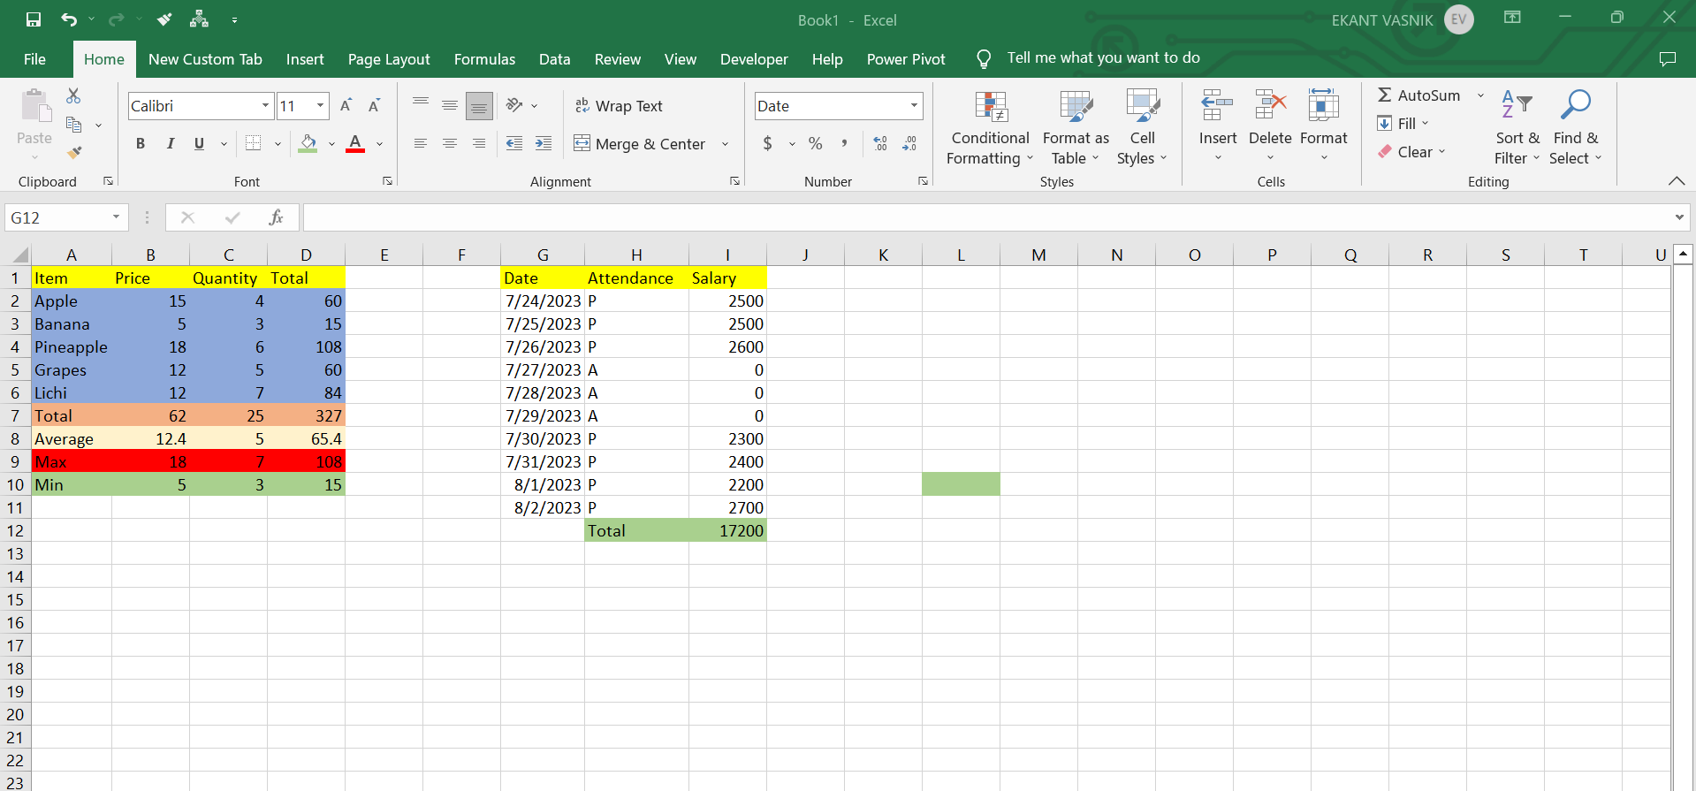

5. Describe flash fill and what the different ways to access the flash fill are.

Flash Fill is a useful feature in Microsoft Excel that automatically fills values in a column based on patterns it recognizes in adjacent cells.

It is designed to save time and effort in data entry and data cleaning tasks. Flash Fill analyzes the data we have entered in one or more columns

and suggests a pattern based on which the remaining data in the column can be filled.

How Flash Fill works:

Enter the data in the first cell of the column where we want to apply Flash Fill.

Excel will detect patterns in the entered data.

If Excel recognizes a pattern, a light bulb icon will appear at the bottom-right corner of the filled cell.

To apply Flash Fill, press "Ctrl + E" or click on the light bulb icon, and Excel will automatically fill the remaining cells in the column based on the recognized pattern.

Different ways to access Flash Fill:

Using Keyboard Shortcut: Press "Ctrl + E" to apply Flash Fill to the column with the pattern.

Using Light Bulb Icon: After entering data in the first cell and if Excel recognizes a pattern, a light bulb icon appears at the bottom-right

corner of the filled cell. Click on the light bulb icon to apply Flash Fill.

Using AutoFill Handle: we can also apply Flash Fill using the AutoFill handle (the small square at the bottom-right corner of the cell).

After entering data in the first cell, drag the AutoFill handle down to fill the remaining cells based on the pattern Excel recognizes.

6. Extract first name and last name from the mail id and then from the

address column, extract the city, state, and pin code using the flash fill.

Given below is an example of the columns we have to create. Paste the

screenshot of what we have created using the flash fill command.

Example: Mail Id, Address, First name, Last name, State, City, Pincode.

